APPENDIX F
USER’S MANUAL
Users manual on how to use the Project Blood Seeker (a web-based blood banking system)
For User:
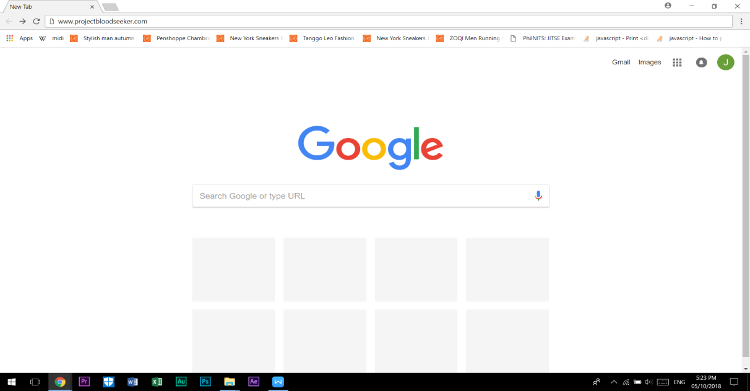
- Search for the link of the web “www.projectbloodseeker.com” by the use of search engines.

- User must click the search tab in order to search blood that needs for their patients.
Search tab

- In order the user can search specific blood type, the user must select the two options that select blood type and city and after select the two options, click the search button.
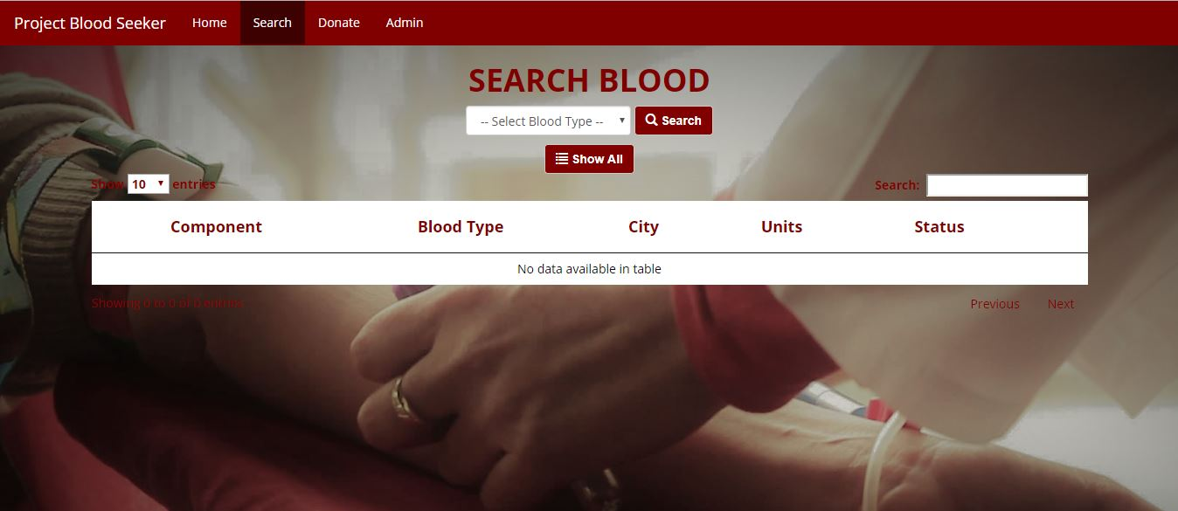
Search button
Dropdown menu
- After the result are filter, the user must click the reserve button, if the blood meet the needs of their patients and the user must wait confirmation by the admin. 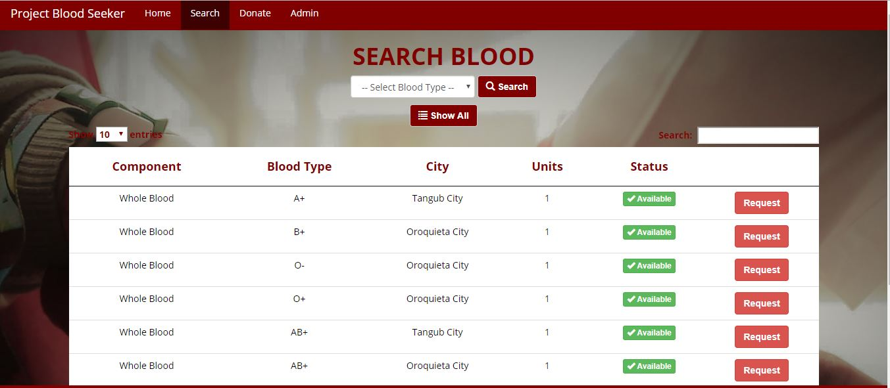
Request button
Results

- When the user done click the request button, the website will appear the request form in order the user will fill up the request form that be given and after finish fill up the required field click the request button.

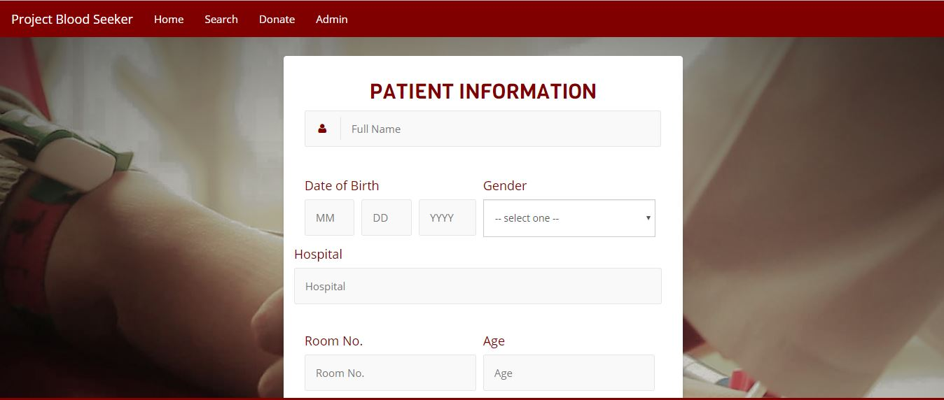
Fill up required fields

For Donor:
- The donor will directly fill up the required given form, click the donate button and wait for the confirmation/notification by the admin.
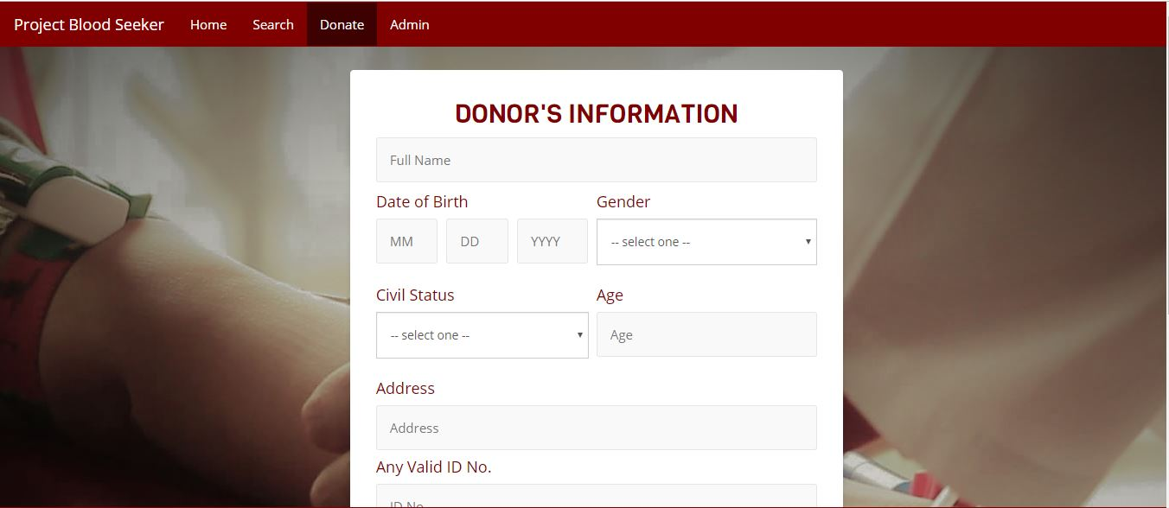
Fill up required fields
For Administrator:
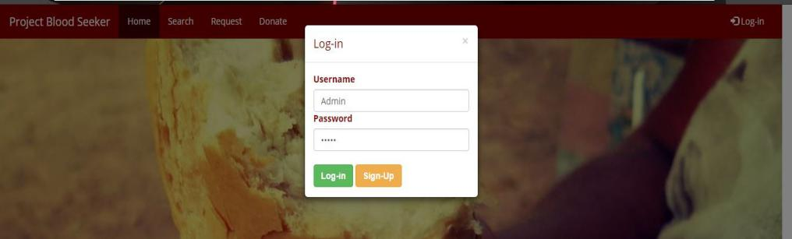
- To access the Admin Side the Administrator must enter username and password and provide authorization to the records of the blood bank being assigned. The Administrator can add record delete specific record and checkout specific record for blood borrower.

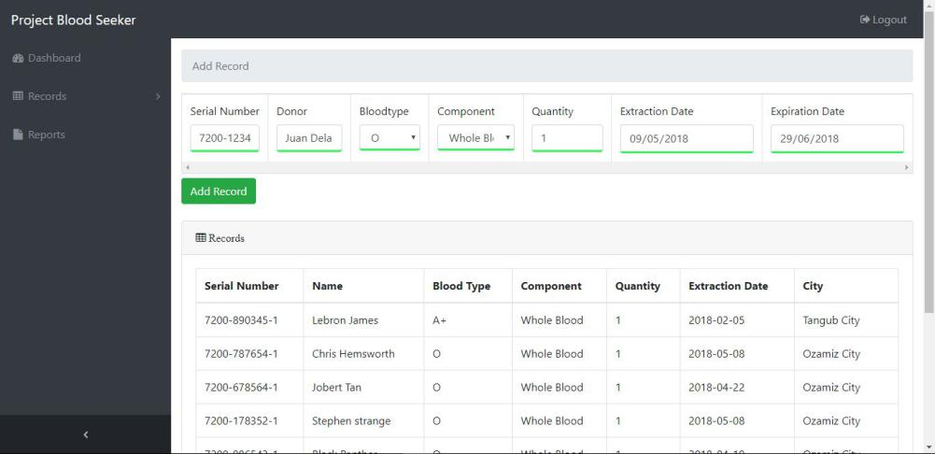

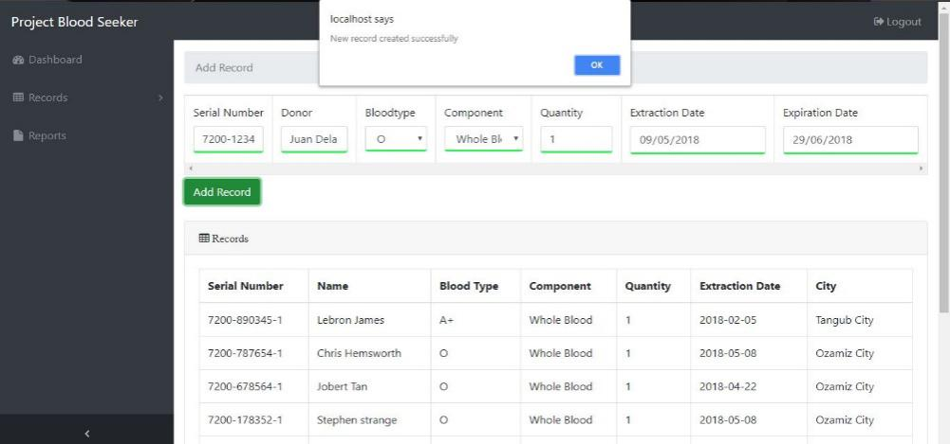

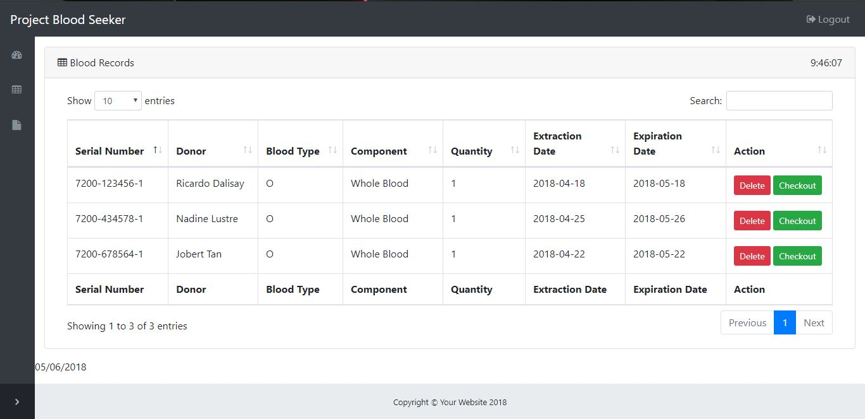

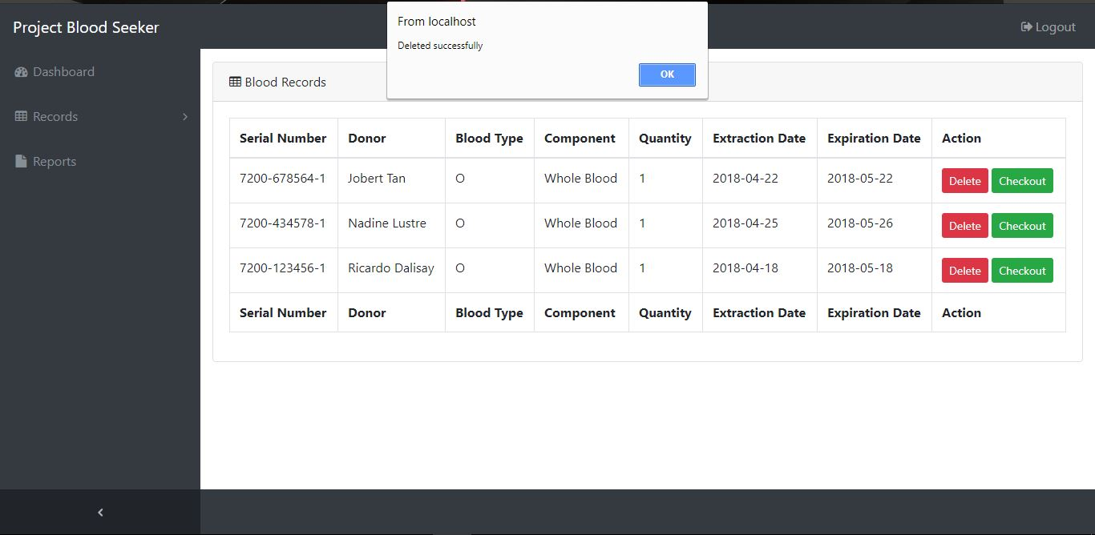

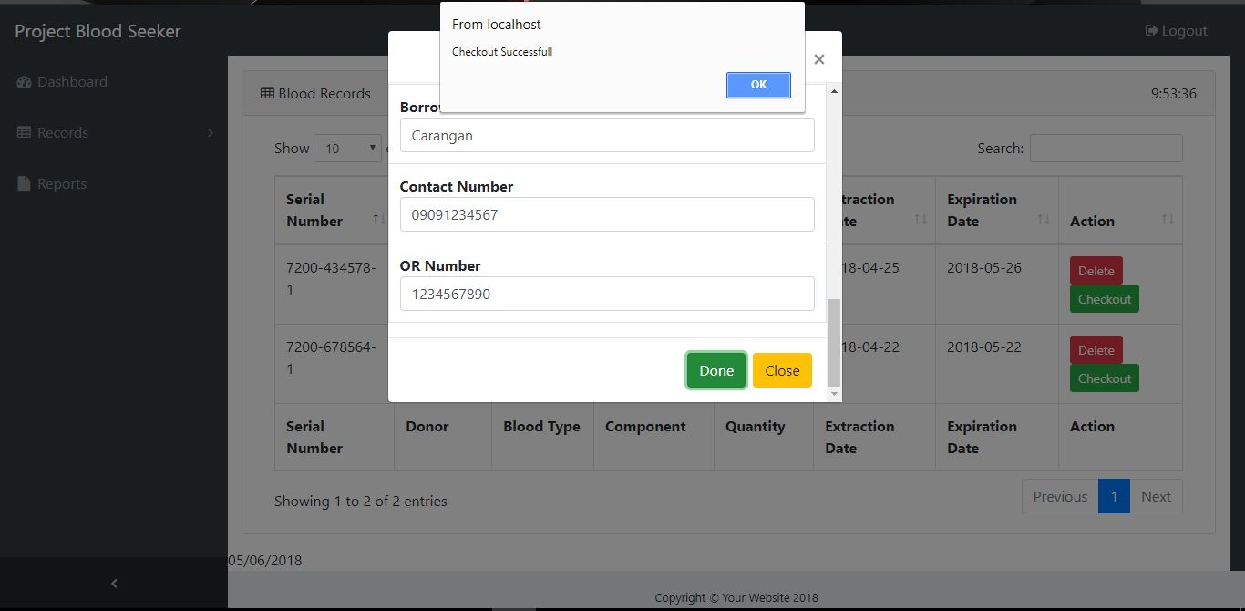

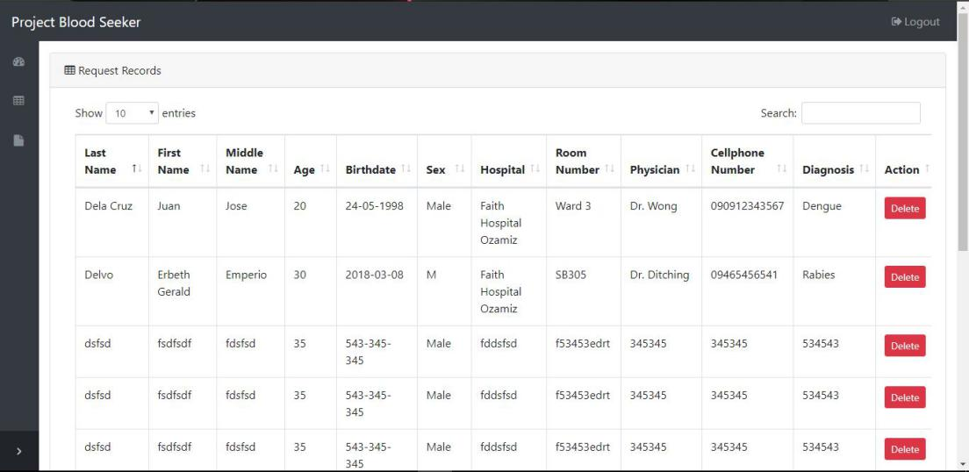
- Also The Admin will check records if there are requested and reserved blood.

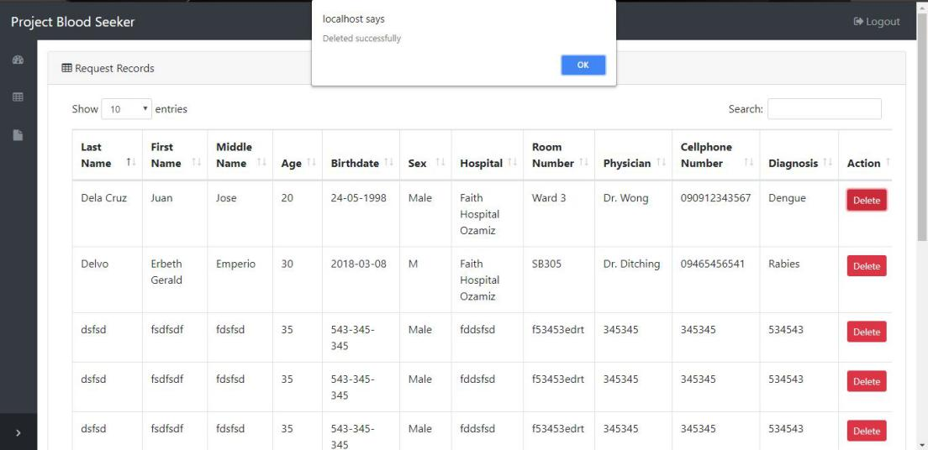

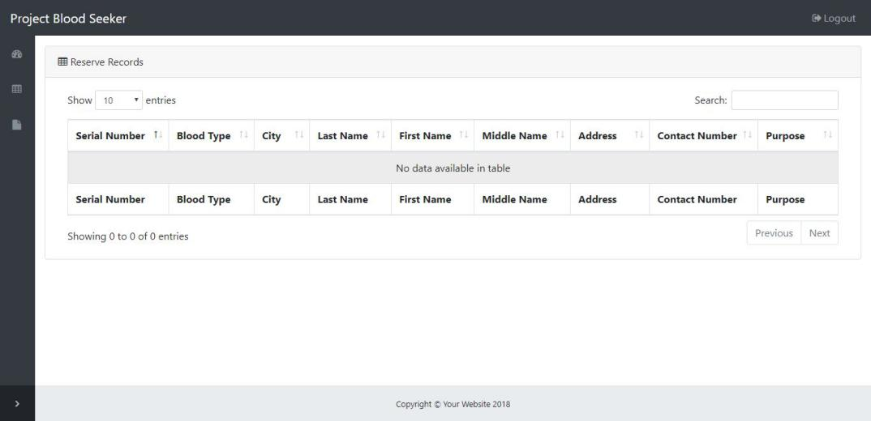

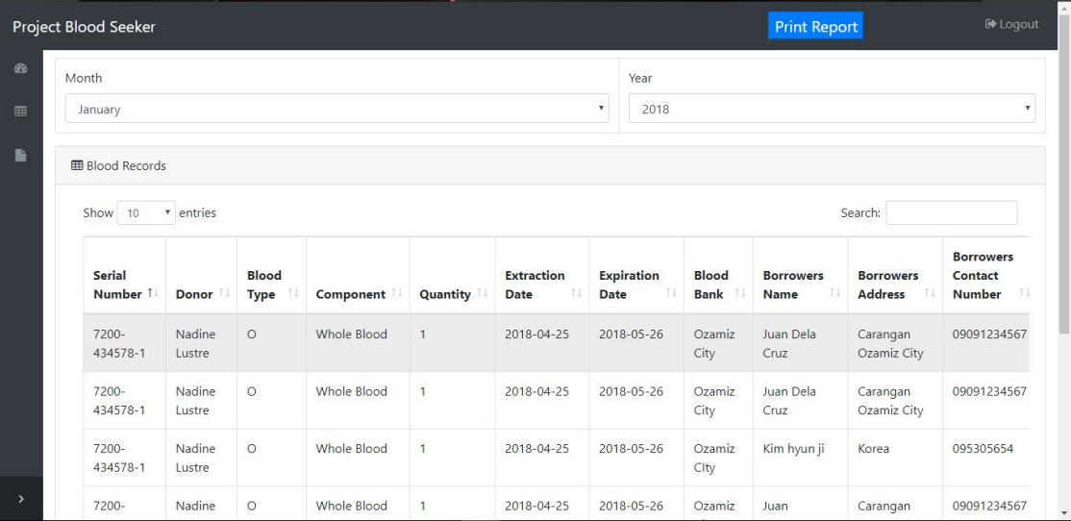
- After all records are check the Administrator will view reports within the selected month and year and print the report.

